KENDRIYA VIDYALAYA NO.1, KOTA

CLASS XII RESULT 2022-23

CLASS XII OVERALL TOPPERS

ROLL No | NAME OF STUDENT | TOTAL | PASS % | STREAM |  | POSITION
11693140 | NIKITA KHANDAL | 481 | 96.2 | HUM |  | I
11693203 | ABHINAV GUPTA | 465 | 93 | SCEINCE | 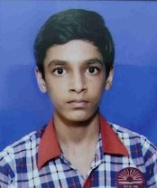 | II
11693285 | SIDDHI SHARMA | 464 | 92.8 | COMM |  | III
11693200 | REKHA | 462 | 92.4 | SCEINCE |  | IV
11693163 | ANKUR CHAUDHARY | 457 | 91.4 | SCEINCE |  | V

STREAM WISE TOPPER

ROLLNo | NAME OF STUDENT | TOTAL | PASS % | STREAM |  | POSITION
11693140 | NIKITA KHANDAL | 481 | 96.2 | HUM |  | I
11693117 | HARSHITA SEN | 454 | 90.8 | HUM | 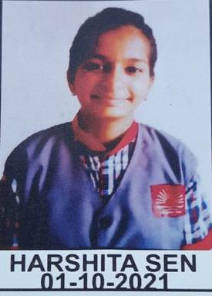 | II
11693116 | GUNJAN JADAWAT | 450 | 90 | HUM |  | III

ROLLNo | NAME OF STUDENT | TOTAL | PASS % | STREAM |  | POSITION
11693203 | ABHINAV GUPTA | 465 | 93 | SCEINCE |  | I
11693200 | REKHA | 462 | 92.4 | SCEINCE |  | II
11693163 | ANKUR CHAUDHARY | 457 | 91.4 | SCEINCE |  | III

ROLLNo | NAME OF STUDENT | TOTAL | PASS % | STREAM |  | POSITION
11693285 | SIDDHI SHARMA | 464 | 92.8 | COMM |  | I
11693257 | DEEPANSHI PARETA | 442 | 88.4 | COMM |  | II
11693268 | KUMARI SONI | 438 | 87.6 | COMM | 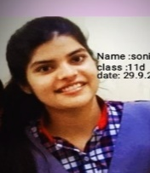 | III

CLASS X RESULT 2022-23

CLASS X TOPPERS

ROLL | NAME OF STUDENT | TOTAL | PASS% |  | POSITION
11204705 | AAYOOSH KUMAR | 483 | 96.6 |  | I
11204601 | SANIDHYA GUPTA | 480 | 96 |  | II
11204672 | GURU PRASAD BHANDARI | 479 | 95.8 |  | III
11204699 | MITANSH VERMA | 477 | 95.4 | 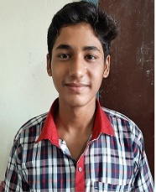 | IV
11204529 | ARUSHI KUMARI | 475 | 95 |  | V

