KENDRIYA VIDYALAYA NO.1 KOTA
CBSE RESULT CLASS XII 2021-22
TOPPERS (OVERALL)

STRAM | TOTAL | APPEARED | PASS | REPEAT | PASS%
SCIENCE | 79 | 78 | 77 | 01 | 98.7
COMMERCE | 28 | 28 | 28 | 0 | 100
HUMANITIES | 60 | 60 | 60 | 0 | 100
TOTAL | 167 | 166 | 165 | 01 | 99.39

APPEARED | PASSED | FAIL AND COMP | ABST | PASS % | 0-32.9 | 33-44.9 | 45-59.9 | 60-74.9 | 75-89.9 | 90-100 | A1 | A2 | B1 | B2 | C1 | C2 | D1 | D2 | E | GRADE COUNT | NXW | PI
166 | 165 | 1 | 1 | 99.39 | 0 | 0 | 13 | 68 | 68 | 19 | 113 | 103 | 119 | 102 | 112 | 119 | 108 | 52 | 4 | 832 | 3922 | 61.13

TOPPERS (OVERALL)
ROLL | PHOTO | NAME | TOTAL | PASS% | POSITION |  |  | STREAM
11683687 | 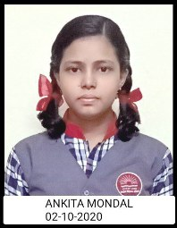 | ANKITA MONDAL | 479 | 95.8 |  | I | SCIENCE
11683718 | 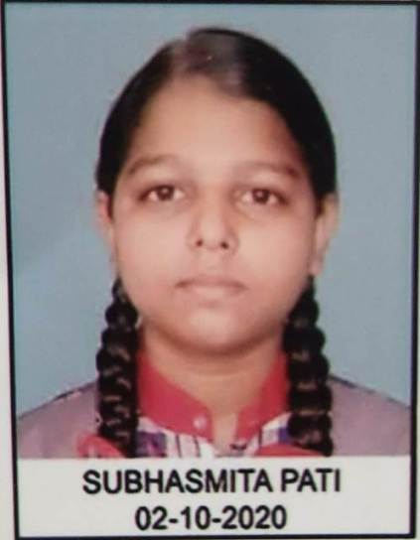 | SUBHASMITA PATI | 479 | 95.8 |  | I | SCIENCE
11683634 | 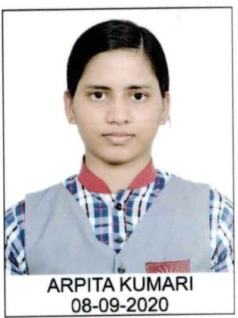 | ARPITA KUMARI | 477 | 95.4 |  | II | HUM
11683708 | 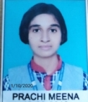 | PRACHI MEENA | 475 | 95 |  | III | SCIENCE
11683724 |  | ABHAY SHARMA | 473 | 94.6 |  | IV | SCIENCE
11683672 | 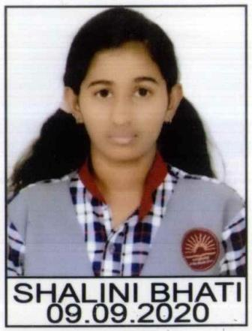 | SHALINI BHATI | 469 | 93.8 |  | V | HUM

KENDRIYA VIDYALAYA NO.1 KOTA
CBSE RESULT CLASS XII 2021-22
SUJECT WISE PI

SUB CODE | SUBJECT | APPEARED | PASSED | PASS% | A1 | A2 | B1 | B2 | C1 | C2 | D1 | D2 | E | PI
302 | HINDI CORE | 138 | 138 | 100.00 | 21 | 17 | 15 | 17 | 16 | 20 | 22 | 10 | 0 | 57.97
27 | HISTORY | 60 | 60 | 100.00 | 12 | 18 | 11 | 9 | 6 | 4 | 0 | 0 | 0 | 76.88
28 | POL SC | 47 | 47 | 100.00 | 6 | 6 | 11 | 11 | 5 | 6 | 1 | 1 | 0 | 67.02
29 | GEOG | 60 | 60 | 100.00 | 5 | 11 | 17 | 8 | 7 | 4 | 8 | 0 | 0 | 65.62
42 | PHYSICS | 78 | 77 | 98.71 | 12 | 9 | 13 | 8 | 10 | 14 | 7 | 4 | 1 | 60.42
43 | CHEMISTRY | 78 | 77 | 98.71 | 15 | 7 | 12 | 7 | 17 | 8 | 6 | 5 | 1 | 61.70
83 | COMP SC | 19 | 18 | 94.73 | 3 | 2 | 4 | 3 | 2 | 4 | 0 | 0 | 1 | 63.82
54 | B .ST | 28 | 28 | 100.00 | 6 | 7 | 2 | 3 | 2 | 5 | 3 | 0 | 0 | 68.30
301 | ENGLISH CORE | 166 | 166 | 100.00 | 9 | 24 | 25 | 20 | 25 | 22 | 35 | 6 | 0 | 55.12
41 | MATHS | 47 | 46 | 97.87 | 9 | 8 | 5 | 9 | 3 | 6 | 3 | 3 | 1 | 64.36
44 | BIO | 40 | 40 | 100.00 | 11 | 4 | 3 | 2 | 11 | 5 | 1 | 3 | 0 | 65.00
30 | ECO | 41 | 41 | 100.00 | 3 | 4 | 3 | 5 | 4 | 6 | 7 | 9 | 0 | 46.34
55 | ACC | 28 | 28 | 100.00 | 7 | 1 | 4 | 3 | 4 | 5 | 2 | 2 | 0 | 62.05
65 | IP | 1 | 1 | 100.00 | 0 | 0 | 0 | 0 | 0 | 0 | 1 | 0 | 0 | 25.00

TOPPERS (SCIENCE)
ROLL | PHOTO | NAME | TOTAL | PASS% | POSITION | STREAM
11683687 | 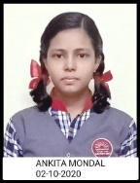 | ANKITA MONDAL | 479 | 95.8 | I | SCIENCE
11683718 | 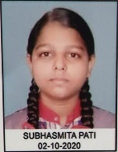 | SUBHASMITA PATI | 479 | 95.8 | I | SCIENCE
11683708 |  | PRACHI MEENA | 475 | 95 | II | SCIENCE
11683724 |  | ABHAY SHARMA | 473 | 94.6 | III | SCIENCE
11683705 | 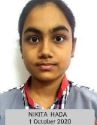 | NIKITA HADA | 468 | 93.6 | IV | SCIENCE
11683754 | 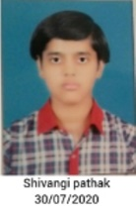 | SHIVANGI PATHAK | 467 | 93.4 | V | SCIENCE

TOPPERS (HUMANITIES)
ROLL | Photo | NAME | TOTAL | PASS% | POSITION | STREAM
11683634 | 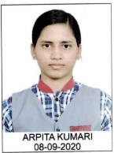 | ARPITA KUMARI | 477 | 95.4 | I | HUM
11683672 | 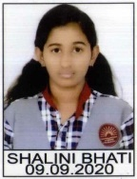 | SHALINI BHATI | 469 | 93.8 | II | HUM
11683644 | 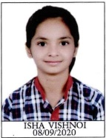 | ISHA VISHNOI | 460 | 92 | III | HUM
11683649 | 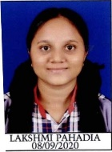 | LAKSHMI PAHADIA | 459 | 91.8 | IV | HUM
11683633 |  | APARNA SHAKYAWAR | 450 | 90 | V | HUM

TOPPERS (COMMERCE)
ROLL | PHOTO | NAME | TOTAL | PASS% | POSITION | STREAM
11683776 |  | QUSAI TINWALA | 449 | 89.8 | I | COMM
11683763 |  | ANUSHREE PRASHANT HIRUDKAR | 445 | 89 | II | COMM
11683782 |  | SHREYA BHARGAVA | 443 | 88.6 | III | COMM
11683760 |  | ABDE ALI PATNAWALA | 437 | 87.4 | IV | COMM
11683783 |  | UNNATI BHATNAGAR | 434 | 86.8 | V | COMM

