KENDRIYA VIDYALAYA NO.1 KOTA
CBSE RESULT CLASS XII 2021-22
TOPPERS (OVERALL)

TOPPERS (OVERALL)

ROLL | PHOTO | NAME | TOTAL | PASS% | POSITION |  |  | STREAM
11683687 | 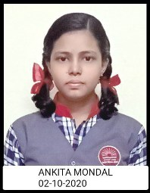 | ANKITA MONDAL | 479 | 95.8 |  | I | SCIENCE
11683718 | 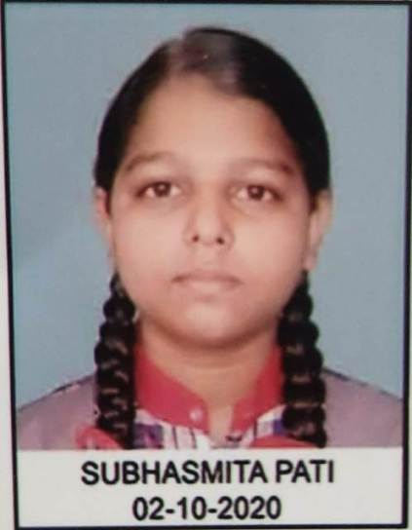 | SUBHASMITA PATI | 479 | 95.8 |  | I | SCIENCE
11683634 | 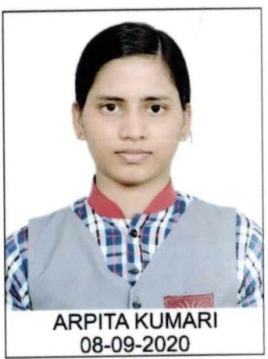 | ARPITA KUMARI | 477 | 95.4 |  | II | HUM
11683708 | 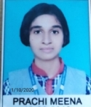 | PRACHI MEENA | 475 | 95 |  | III | SCIENCE
11683724 |  | ABHAY SHARMA | 473 | 94.6 |  | IV | SCIENCE
11683672 | 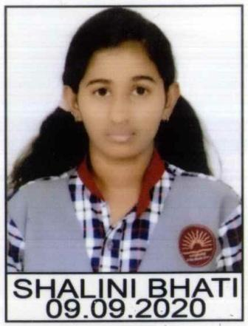 | SHALINI BHATI | 469 | 93.8 |  | V | HUM

TOPPERS (SCIENCE)
ROLL | PHOTO | NAME | TOTAL | PASS% | POSITION | STREAM
11683687 | 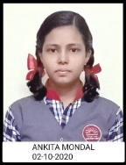 | ANKITA MONDAL | 479 | 95.8 | I | SCIENCE
11683718 | 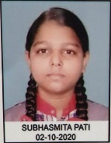 | SUBHASMITA PATI | 479 | 95.8 | I | SCIENCE
11683708 |  | PRACHI MEENA | 475 | 95 | II | SCIENCE
11683724 |  | ABHAY SHARMA | 473 | 94.6 | III | SCIENCE
11683705 | 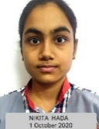 | NIKITA HADA | 468 | 93.6 | IV | SCIENCE
11683754 |  | SHIVANGI PATHAK | 467 | 93.4 | V | SCIENCE

TOPPERS (HUMANITIES)
ROLL | Photo | NAME | TOTAL | PASS% | POSITION | STREAM
11683634 | 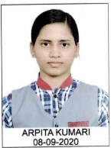 | ARPITA KUMARI | 477 | 95.4 | I | HUM
11683672 | 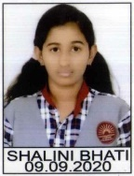 | SHALINI BHATI | 469 | 93.8 | II | HUM
11683644 | 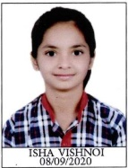 | ISHA VISHNOI | 460 | 92 | III | HUM
11683649 | 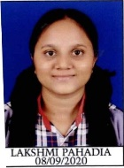 | LAKSHMI PAHADIA | 459 | 91.8 | IV | HUM
11683633 |  | APARNA SHAKYAWAR | 450 | 90 | V | HUM

TOPPERS (COMMERCE)
ROLL | PHOTO | NAME | TOTAL | PASS% | POSITION | STREAM
11683776 |  | QUSAI TINWALA | 449 | 89.8 | I | COMM
11683763 |  | ANUSHREE PRASHANT HIRUDKAR | 445 | 89 | II | COMM
11683782 |  | SHREYA BHARGAVA | 443 | 88.6 | III | COMM
11683760 |  | ABDE ALI PATNAWALA | 437 | 87.4 | IV | COMM
11683783 |  | UNNATI BHATNAGAR | 434 | 86.8 | V | COMM

